**IOT-HMI**

**ABSTRACT**

**WHAT IS HMI:**

HMI, in its simplest terms, includes any device or software that allows you to interact with a machine. This can be as simple and ubiquitous as the traditional single-touch display mounted on a machine or as technologically advanced as a multi-touch-enabled control panel.

**AIM OF PROJECT:**

* Enable start up logo on LCD in u-boot.
* Enable touch screen in kernel space.

**BLOCK DIAGRAM:**

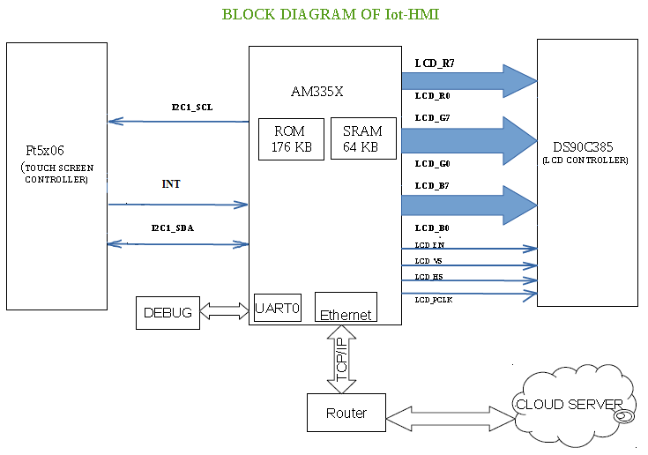

**HARDWARE AND SOFTWARE REQUIRMENTS:**

**HARDWARE:**

* AM335X SOC
* LCD(DS90C385)
* Touch Screen(FT5X06)
* Ethernet

**SOFTWARE:**

* Linux kernel(3.14)
* Android 4.4(kitkat)

**PROJECT DESCRIPTION:**

The main aim of project is to interface different controllers like touch panel (FT5X06) and LCD controller (DS90C385) using AM335x processor. The communication systems used to interface these devices are I2C and RGB. This information is also sent to web application through Ethernet or wi-fi module.

The touch screen we use for this project is capacitive touch screen. This consists of a glass overlay, coated with a conductive material such as Indium Tin Oxide. Contact with a capacitive screen creates an electrostatic charge that sends information to the touch control in order to perform its function. Based on the INT signals and I2C communication the touch panel data is sent to processor.

In this we are also interfacing 7 inch LCD to AM335X processor through 24 bit RGB communication. The main aim is to initialize LCD and start up logo on LCD in u-boot.

**HMI APPLICATIONS:**

HMIs can be found in multiple locations such as portable handheld devices, on machines, centralized control rooms, as well as factory floor machine and process control. Applications include industrial and building automation, digital signage, vending machine, medical, automotive, and appliances.